Alexander Baldree
03/11/26
Module 11.2 Assignment
CSD340

GitHub Link:
https://github.com/Panda-Alex21687/CSD340

11.2 Assignment:
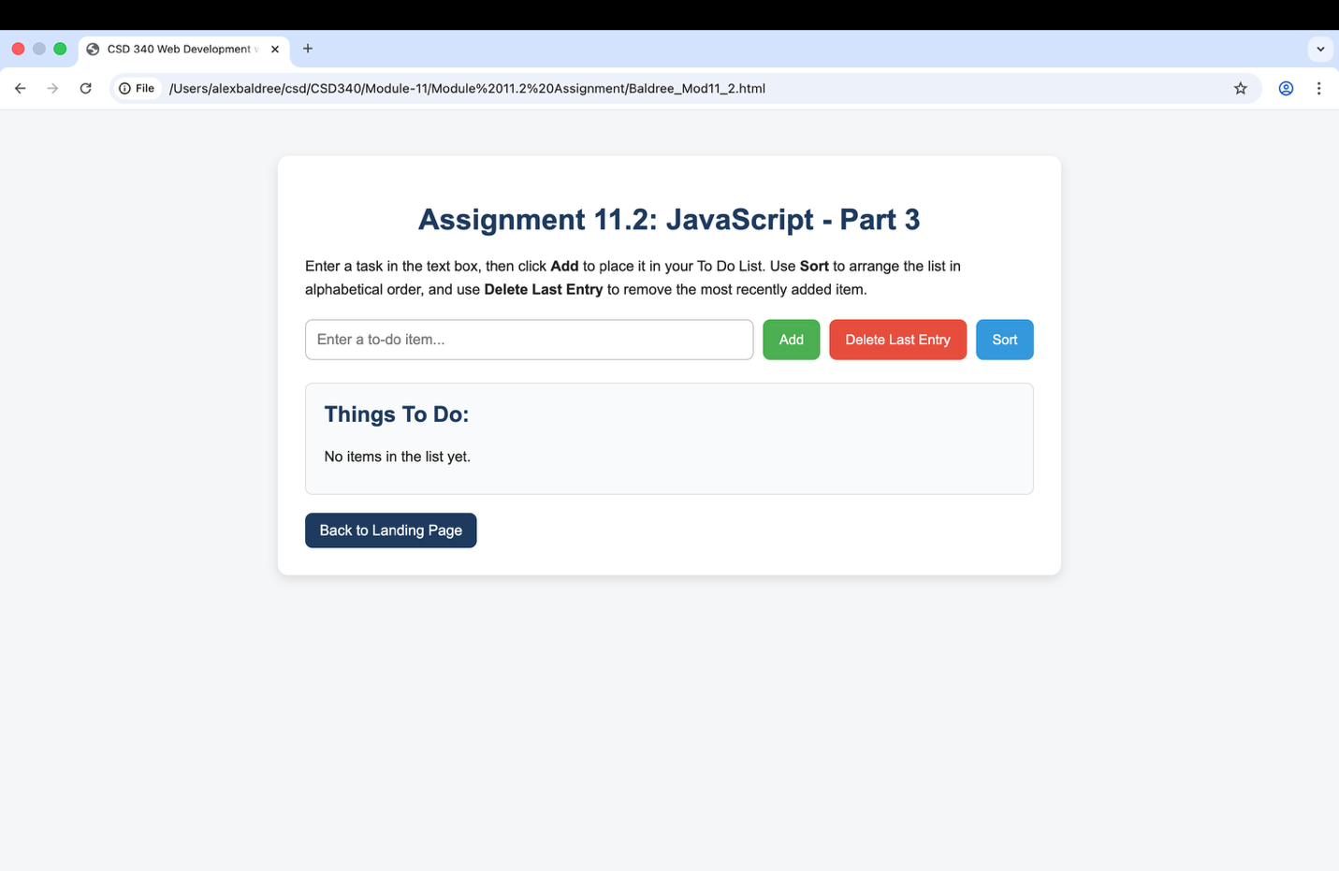

Added Items and task not in order:
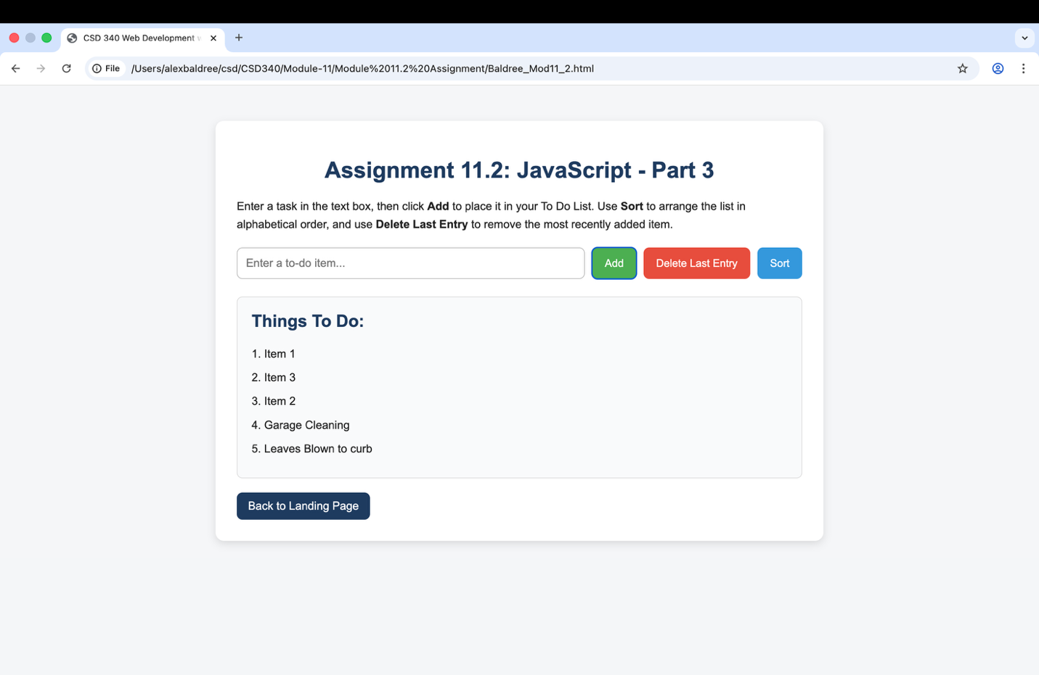

Item Deleted form list:
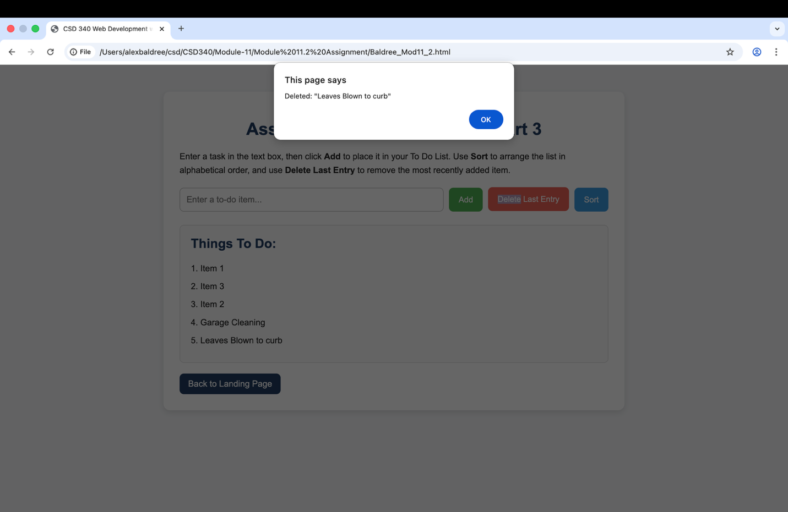
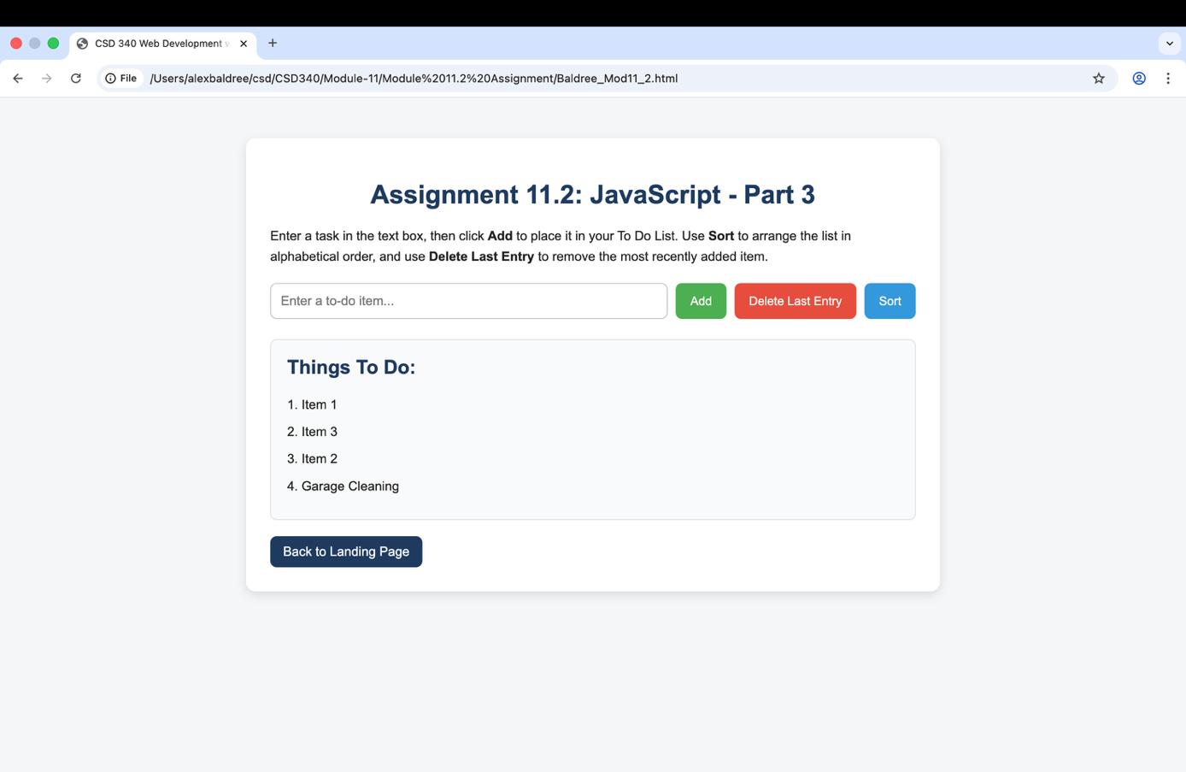

Item Sorted:
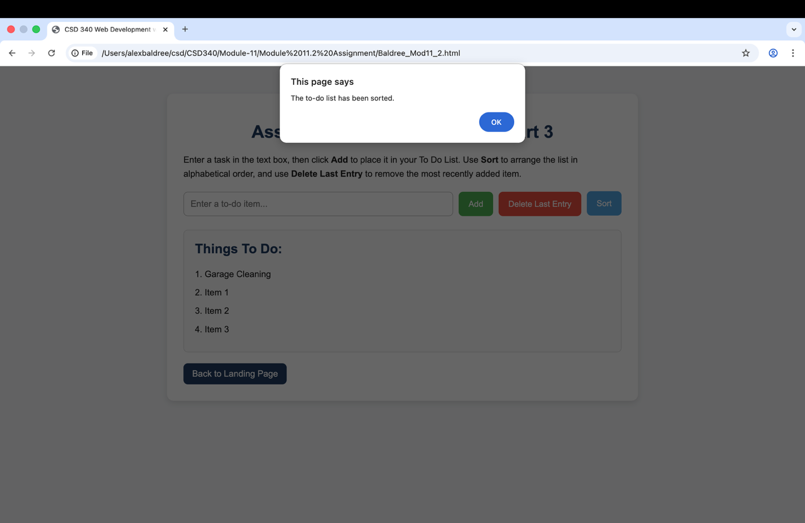
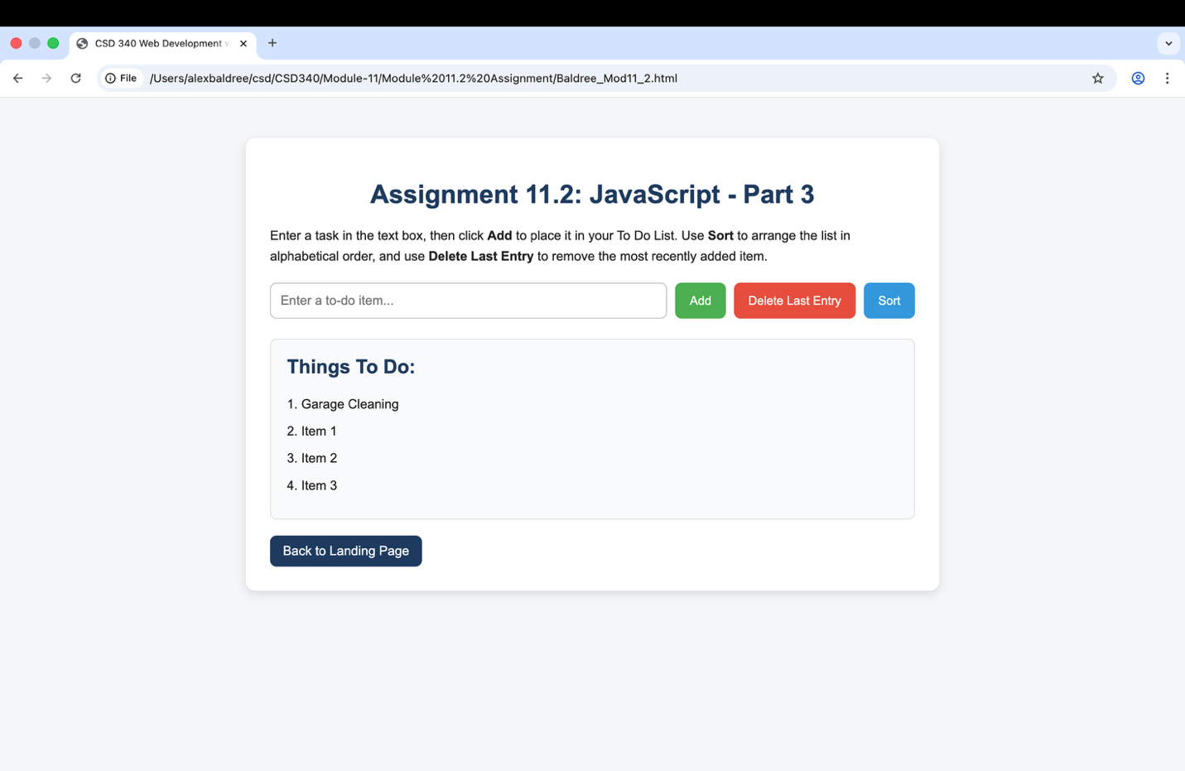
HTML:
<!DOCTYPE html>
<html lang="en">
<head>
<meta charset="UTF-8" />
<meta name="viewport" content="width=device-width, initial-scale=1.0" />
<title>CSD 340 Web Development with HTML and CSS</title>
<link rel="stylesheet" href="Baldree_Mod11_2.css" />
</head>
<body>
<div class="container">
<h1>Assignment 11.2: JavaScript - Part 3</h1>

<p>
Enter a task in the text box, then click <strong>Add</strong> to place it in your
To Do List. Use <strong>Sort</strong> to arrange the list in alphabetical order,
and use <strong>Delete Last Entry</strong> to remove the most recently added item.
</p>

<div class="input-section">
<input type="text" id="todoInput" placeholder="Enter a to-do item..." />
<button class="add-btn" onclick="addItem()">Add</button>
<button class="delete-btn" onclick="deleteLastItem()">Delete Last Entry</button>
<button class="sort-btn" onclick="sortItems()">Sort</button>
</div>

<div class="list-display" id="displayArea">
<h2>Things To Do:</h2>
<p>No items in the list yet.</p>
</div>

<a class="back-link" href="../../index.html">Back to Landing Page</a>
</div>

<script>
let todoList = [];

function displayItems() {
let displayArea = document.getElementById("displayArea");

if (todoList.length === 0) {
displayArea.innerHTML = `
<h2>Things To Do:</h2>
<p>No items in the list yet.</p>
`;
return;
}

let output = "<h2>Things To Do:</h2>";
for (let i = 0; i < todoList.length; i++) {
output += "<p>" + (i + 1) + ". " + todoList[i] + "</p>";
}

displayArea.innerHTML = output;
}

function addItem() {
let input = document.getElementById("todoInput");
let item = input.value.trim();

if (item === "") {
alert("Please enter a to-do item before clicking Add.");
return;
}

todoList.push(item);
alert('Added: "' + item + '"');
input.value = "";
displayItems();
}

function deleteLastItem() {
if (todoList.length === 0) {
alert("There are no items to delete.");
return;
}

let deletedItem = todoList.pop();
alert('Deleted: "' + deletedItem + '"');
displayItems();
}

function sortItems() {
if (todoList.length === 0) {
alert("There are no items to sort.");
return;
}

todoList.sort();
alert("The to-do list has been sorted.");
displayItems();
}
</script>
</body>
</html>

CSS:
body {
font-family: Arial, Helvetica, sans-serif;
background-color: #f4f6f8;
margin: 0;
padding: 0;
color: #222;
}

.container {
max-width: 800px;
margin: 50px auto;
background: #ffffff;
padding: 30px;
border-radius: 12px;
box-shadow: 0 4px 12px rgba(0, 0, 0, 0.12);
}

h1 {
text-align: center;
color: #1f3a5f;
margin-bottom: 20px;
}

p {
line-height: 1.6;
}

.input-section {
display: flex;
flex-wrap: wrap;
gap: 10px;
margin: 20px 0;
}

input[type="text"] {
flex: 1;
min-width: 250px;
padding: 12px;
font-size: 16px;
border: 1px solid #bbb;
border-radius: 8px;
}

button {
padding: 12px 18px;
font-size: 15px;
border: none;
border-radius: 8px;
cursor: pointer;
transition: 0.3s ease;
}

.add-btn {
background-color: #4caf50;
color: white;
}

.delete-btn {
background-color: #e74c3c;
color: white;
}

.sort-btn {
background-color: #3498db;
color: white;
}

button:hover {
opacity: 0.9;
transform: translateY(-1px);
}

.list-display {
margin-top: 25px;
padding: 20px;
background-color: #f9fafb;
border: 1px solid #ddd;
border-radius: 8px;
}

.list-display h2 {
margin-top: 0;
color: #1f3a5f;
}

.list-display p {
margin: 8px 0;
}

.back-link {
display: inline-block;
margin-top: 20px;
text-decoration: none;
background-color: #1f3a5f;
color: white;
padding: 10px 16px;
border-radius: 8px;
}

.back-link:hover {
background-color: #16304d;
}

